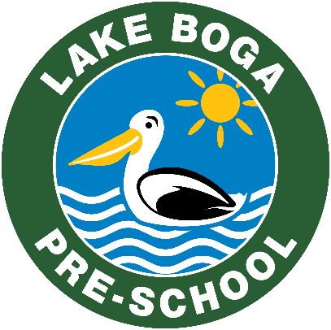
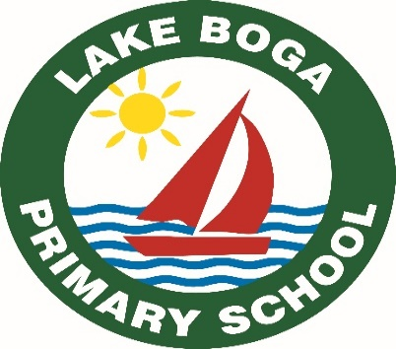
Lake Boga Educational Hub
‘Be the best that we can be’
Principal: Joe Summerhayes
8 Williams Road, Lake Boga 3584
5036 9000
lakeboga.vic.gov.au

on-site attendance form (Term 3)
Student/s name:
Student/s date of birth:
Student/s year level:
Victorian government schools in rural and regional Victoria will commence remote and flexible learning from 5 August 2020 for all students except for students enrolled in specialist schools. | ☐ I am requesting that my child/ren attend on-site learning because my child/ren is/are not able to be supervised at home and no other arrangements can be made as l am unable to work from home.  OR  ☐ My child identifies as vulnerable and I am requesting they attend on-site learning as they fall under this category.  OR  ☐ My child/ren has a disability* and I am requesting they attend on-site learning based on parent choice.  * ‘Disability’ refers to all students receiving adjustments, including (but not limited to) those supported through the Program for Students with Disabilities.  By submitting this form, I declare that my child/ren is/are well and I will collect my child/ren as soon as is practicable upon the request of the school if my child becomes unwell.
Dates required:  Please note you need to complete this process weekly to ensure adequate staffing onsite. | Day Date AM, PM or ALL DAY  Monday  Tuesday  Wednesday  Thursday  Friday
Emergency contact details:

Parent/Guardian name: _________________________________________________

Signature: ____________________________________________________________

Date: _______________________________________________________________

Received and Processed by……………………….. on (date)……………………………………

